Defibrillator and associated kit

The defibrillator is a device that delivers a therapeutic dose of electrical energy to the affected heart. This electrical impulse actually in effect stops the heart in order to attempt to restart it.

The algorithm below details where a defibrillator would come into use during a resuscitation.

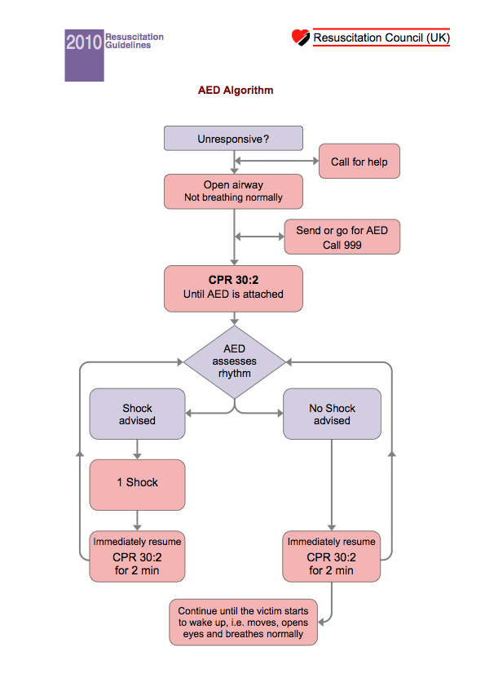

Attached onto the defibrillator there is a safety sticker which details the safety checks that much be performed in order to defibrillate safely.

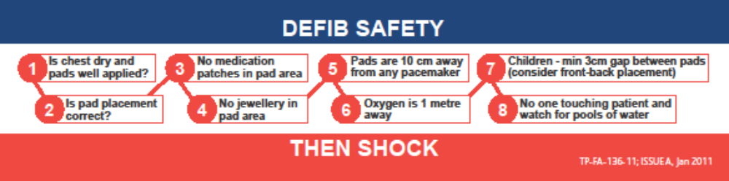

Pad placement is also important and is shown in the pictures –

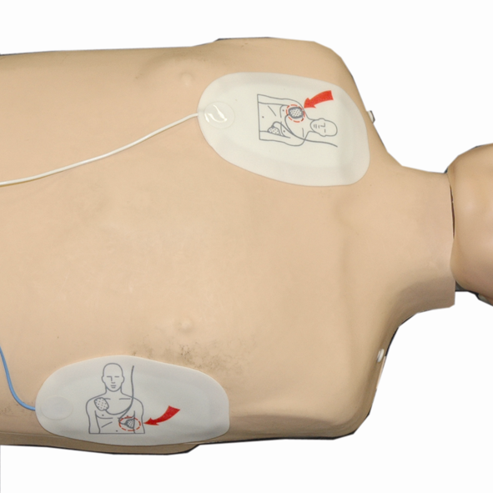
Adult pad placement

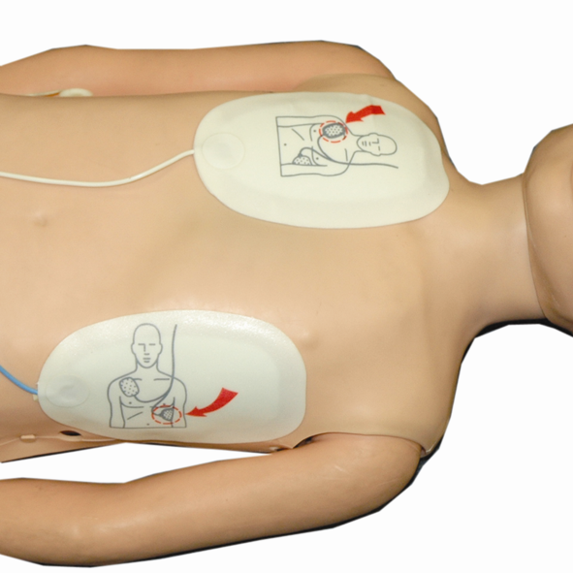

Child pad placement

Additional kit with the defibrillator includes a set of defibrillator pads, a pair of shears to cut through any clothing, a razor to shave the pad area if required and a towel to dry the patient if they are wet.

